UNITED INTERNATIONAL UNIVERSITY

Department of Computer Science and Engineering (CSE)
1 hr
Course : DSA II Lab |  | Course Code: CSE 2218
Name : |  | ID:
Final Exam
SN | Questions | Marks
1 | You have entered into an ancient pyramid in search of the treasure of the Pharaoh Demsis. There are several tunnels and routes inside the pyramid. Thankfully you have a map which is helping you to effectively navigate through the routes. The map depicted in the form of a graph is shown in the given figure.  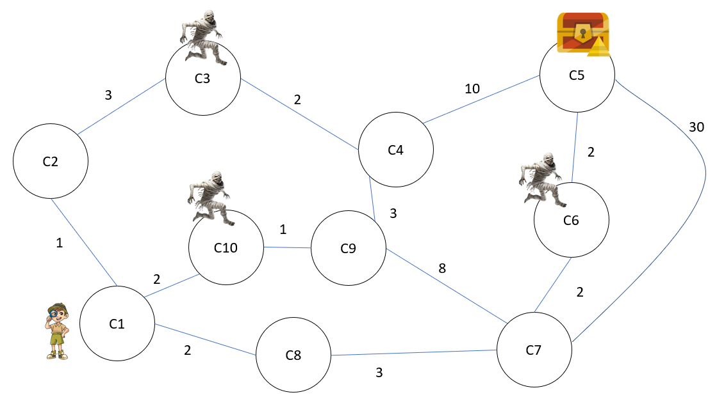  Observe that there are several chambers in the pyramid (C1, C2, C3, …, C10) which are connected to each other by different routes . The edges denote the length of these routes. Note that some of the chambers have mummies inside them. You want to go to the chamber with the treasure as shown in the figure by avoiding the chambers with the mummies and by going through the shortest possible path.  Using Dijkstra’s algorithm, determine the safe shortest path for the above graph. Note that your code will be checked using other sample inputs as well so make sure that the graph input is dynamic and obtained from the user. Observe the sample input and output. First insert the number of chambers followed by the number of routes. Then enter 0 for those chambers which are without any mummies and 1 for the chambers with mummies.  Finally enter the edges in the format (u,v,w). The given sample input and output is as per the above diagram.  Sample Input Sample Output  10 13 1 2 1 2 3 3 3 4 2 4 5 10 5 7 30 8 7 3 1 8 2 1 10 2 10 9 1 9 4 3 9 7 8 6 7 2 6 5 2 0 0 1 0 0 1 0 0 0 1 5 Safe Path: ->1->8->7->9->4->5 The total length of the safe route is: 26  Input 2 _____ Dijkstra Implementation 2 ____ Code modification 4 ____ Correctness 2 _____ | 10

SN | Questions | Marks
2 | After venturing through those mummie filled routes, you have finally entered into the chamber of the pharaoh’s tomb. And hurrah! You have found the treasure. You have brought with you several bags in order to carry the items.  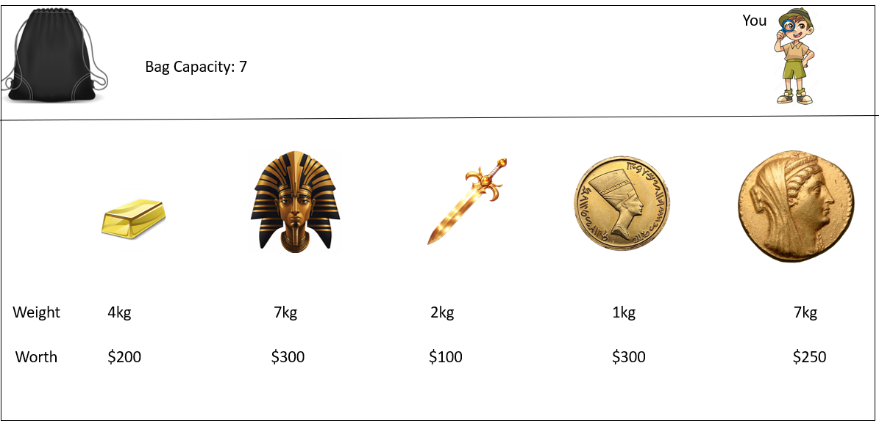  Now, using a Dynamic Programming Approach, determine the number of bags you will be using in order to take all the items from the Pharaoh’s Tomb. The given sample input and output has been provided as per the above figure, but note that your code will be tested using other sample inputs as well.  Sample Input Sample Output  5 7 4 7 2 1 7 200 300 100 300 250 Using the knapsack no 1 Taken item 1 Taken item 3 Taken item 4 profit = 600 Using the knapsack no 2 Taken item 2 profit = 300 Using the knapsack no 3 Taken item 5 profit = 250 Using the knapsack no 4 profit 0  Input 1 _____ DP Implementation 2 ____ Code modification 5 ____ Correctness 2 _____ | 10

